**Write a C program to find Odd or Even number from a given set of numbers**

**INPUT:**

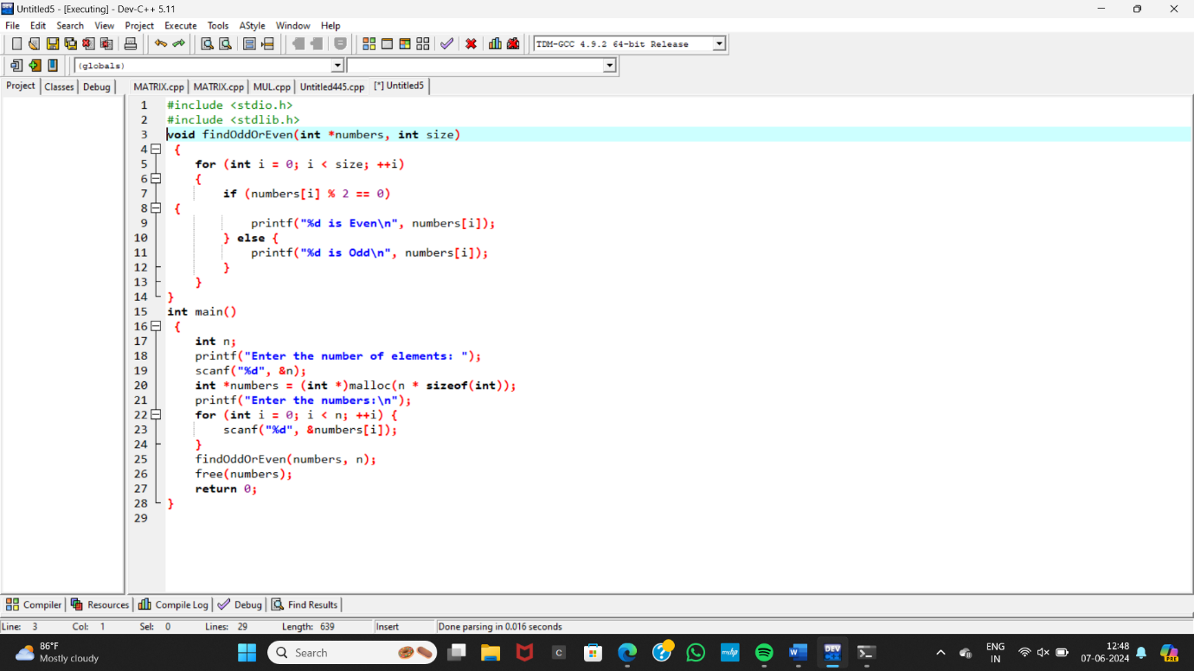

**OUTPUT:**

